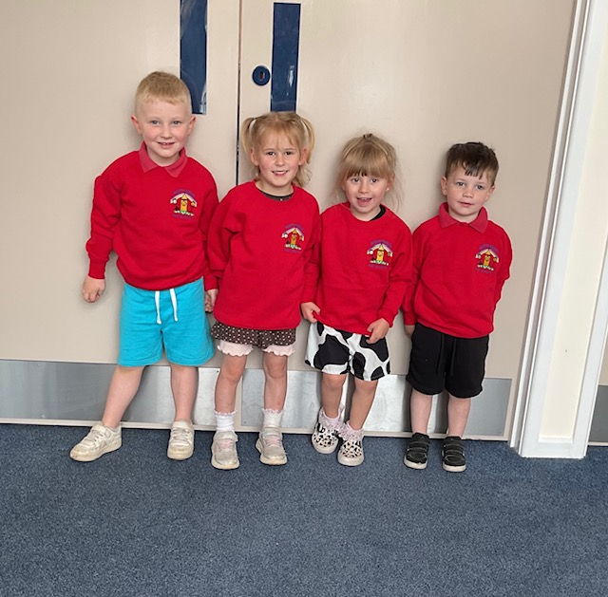
North Nibley Preschool Uniform Order
Please return this form to dyerj321@gmail.com
Your child wearing preschool uniform to preschool is entirely up to you. The option is there if you wish to, we sell polo shirts and sweatshirts. We do not make any profit on these items, but we know that children really enjoy wearing their uniform and are very proud of it! If you choose to order, an invoice will be sent to you via email. BACS transfer for payment is preferred. We keep a small stock at preschool, and we can order from the supplier when needed. We collect the items, and you collect from preschool. Sizing comes in the following sizes age two years, three to four years and five to six years. We nearly always have a sample for you to try.
Name of child

ITEM | SIZE | QUANTITY
Polo Shirt (£9.50 each)
Sweatshirt (£12.25 each)

